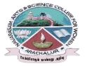
NAVARASAM ARTS AND SCIENCE COLLEGE FOR WOMEN
ARACHALUR, ERODE-638101
STAFF PROFILE
Name | K BANU PRIYA.  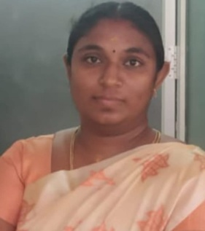
Designation | Assistant Professor
Qualification | MA.,MEd.,MPhil.,(PhD)
Department | Department of Tamil
Phone No. | Office
 | Mobile | 7538886656
Email | 1.banupriyamed2020@gmail.com
Areas of Interest/  Specialization | ARA ILAKKIYAM
Subjects Taught | UG:  1)KANIPPURIUM INAIYAMUM  2)THAMILAGA VARALARUM  PANPADUM  3)ILAKKIYATH THIRANAIVU  4)POTHUMOZIYAL  5)KOILKALAIKAL  PG: OPPILAKKIYA ARIMUGAM  INTHIYA MOZIKALIN VARALARU  THOLKAPPIYAM ELUTHTHU  THOLKAPPIYAM PORUL
Date of Joining in our Institution | 01/10/2021
Experience (in Years) | Industry
 | Teaching |  | 5years
 | Research
 | Total
Research Publications in Journals | UGC arimanooku-1Paper, ISBN-2Paper
Papers Published in Conference Proceedings | Nil
Books / Chapters  Published | NIL
Patent Published | NIL

Research Projects  Major/ Minor | Completed |  | -
 | Undergoing |  | -
Research Guidance | Awarded |  | Undergoing
 | - |  | -
Conferences | Attended | Presented |  |  | Organized
National | - | - |  |  | -
International | - | - |  |  | -
Workshops | Attended |  |  | Organized
 | 1
FDP | Attended |  |  | Organized
 | 3 |  |  | NIL
Seminar / Webinar | Attended |  |  | Organized
 | 2 |  |  | NIL
Membership | NIL
Acted as Resource Person | NIL
Awards | NIL
Online Courses | Completed |  |  | Enrolled
 | NIL |  |  | NIL
Extension Activities (NSS/YRC) / Club In charge | Nil
Administrative Assignments Handled | Nil
Association with Professional Bodies | Nil
Anyother Achievements | NIL
Orchid / Google Scholar/  Research ID | Banu Priya K

